EVENTS THIS MONTH
The Lighthouse is the name of two things; It’s our Venue on Hargham Road where our offices are based and which is available for hire to local groups and it’s also the name of a charitable company we started ten years ago to serve the needs of the local community. Here’s our activities this month:
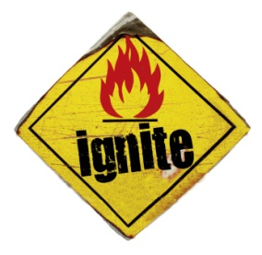
ignite youth project it’s all about relationship
Girls' Lounge - After-school Drop-In - every Thursday 3.30-4.30pm
@ The Coffee Lounge
Friday Drop-In - 8-10pm @ The Francis Room - 3rd Nov
Friday Detached - 8-10pm on the streets - 10th, 17th and 24th Nov
IT Made Simple - 1.30-3pm @ The Lighthouse - Wed 8th, 22nd Nov
Life Stories - 1.30-3pm @ The Lighthouse - Fri 17th Nov
Contact: Debs Carter (debs.carter@christcommunitychurch.co.uk)

Every Friday in November – 10am til 11.30am at the Lighthouse.
Contact: Sara Govey (saragovey@gmail.com)

TREASURES – Befriending and Supporting older people.
Monthly Coffee Morning – Tuesday 28th November 10am
Contact: Ruth Oyeniyi (royeniyi2002@yahoo.co.uk)

Contact Details:
Church Office – 01953 452865 – info@christcommunitychurch.co.uk
The Lighthouse, 131 Hargham Road, Attleborough NR17 2JP
Rob Tervet, (Church leader): rob@christcommunitychurch.co.uk (off on Saturday)
Liz Keogh (Administrator): liz@christcommunitychurch.co.uk (Liz works Tues & Fri)
Paige Morgan Durand (Trainee Evangelist, Alpha): paige@christcommunitychurch.co.uk
Matt Rushby (Events and Worship Leader):
mattrushby@hotmail.co.uk (Matt works Sundays, Thursdays and Friday mornings)
The elders (leaders) of the Church are Rob Tervet and James Oyeniyi.
Christ Community Church, Attleborough is in partnership with Relational Mission, which is part of Newfrontiers
NOVEMBER NEWS

NOVEMBER EVENTS

Sunday Services  10.30am every week at Attleborough Community Hub (Independence Matters, Station Road).  5th November – Adam Mason  12th November – Matt Rushby  19th November – Rob Tervet  26th November – Adam Mason | Teaching series: 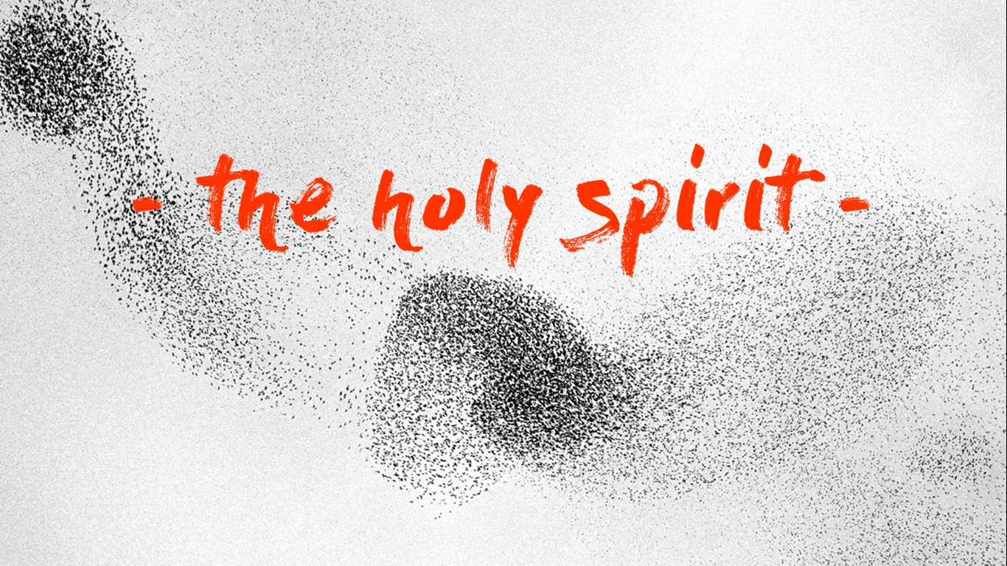
Every week: Prayer triplets – Gathered in His name
Want to get plugged into Christ Community Church? At the moment this happens in prayer triplets. If you would like to join a group or find out more please contact Rob rob@christcommunitychurch.co.uk

Alpha – Tuesday Nights, at the Lighthouse 7pm.
Contact Paige for more info: paige@christcommunitychurch.co.uk

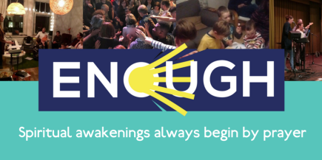 | Enough – 10th November, 7pm -11pm, The Kings Centre, Norwich.  Enough gathers thousands across our family of churches for special nights of prayer three times a year.
Dedications – Sunday 12th November
We’ll be taking time in the service to give thanks for new life, followed by a bring and share lunch at the Hub.

Prayer Triplets combined - Wednesday 22nd November, 8pm at the Lighthouse. We’ll be gathering all the prayer triplets together once a month, join us for worship, prayer and encouragement.

Girls only – Saturday 11th November, 8pm.
A social event for the ladies. Bring yourself, a drink, a friend and some cash as there will be greeting cards for sale. Gloucester House, 51 Mill Lane, Attleborough, NR17 2NW. Hosted by Emily emily@christcommunitychurch.co.uk

OLDER YOUTH (years 10-13)
SUNDAY NIGHTS |  | 19th November – Escape Room @ 62 Norwich Road 7.30pm – 9.30pm.
SUNDAY MORNINGS  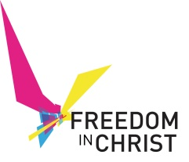 | On these Sundays we’re working through a great course called ‘Freedom in Christ for Young people’. It’s a mixture of videos, activities and discussion.  5th November – Worldview  12th November – Big choices  26th November – Strongholds

Youth Weekend Away November 24-26
Letton Hall
Book here: ywa.org.uk

OTHER DATES COMING UP:

Christmas at Christ Community Church:
10th Dec, 17th Dec: Special Sundays at the HUB usual time
19th December – Christmas Drinks and Nibbles 8pm. Venue TBC
23rd December - 4.30pm Carols by Candlelight Service at the Lighthouse.
24th December – 10.30am Shorter Nativity service at the Lighthouse
25th December – No service
31st December – No service

13th December – Prayer Triplets combined

16th December - Guys and Girls Combined

