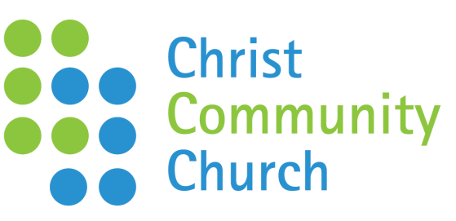 | MARCH  News Update
Welcome to Christ Community Church! We’re passionate about Jesus with a big heart for our town. We believe God has called us to be a Church impacting every layer of the community. If you would like to stay in touch please visit our welcome board and complete a welcome card.

Sunday Services:
Dates |  | Details |  | Speaker
6th March |  | TBC |  | Rob Tervet
13th March |  | TBC |  | Adam Mason
20th March |  | Guest Speaker – stand alone |  | Marcus Tutt
27th March |  | Easter Sunday Celebration |  | TBC

Easter Sunday |  |  |  | We’re having an all age celebration at 11am at Attleborough Junior School followed by baptisms and a Hog Roast at the Lighthouse.  Tickets for the Hog Roast are £5 per head and include sides and drinks. Tickets can be purchased on Sunday or booked by calling 01953 452865.
Coming up: Treasures Spring Tea Party
Saturday 5th March, 2-5pm at the Lighthouse. We’re going to be Treasuring our senior citizens with a special afternoon.

Daytime Alpha Course
Starting 1st March, Tuesdays 12 – 1.30pm @ Pete and Avi’s House. Free lunch included and childcare available. The Limes, 3 Chapel Road (accessed via Leigh Close NR17 2DR). Call 01953 452865 to book a place.
There are so many great books to read about the Christian faith that keep us stirred and growing in our walk with Jesus. Debs Page is leading a weekly Book Club on Thursdays 11.30am til 12.30pm, at 17a Arlington Gardens. Contact Debs on 07931 783202 to join.

Coffee Morning
Christine Tervet has an open house most Wednesday mornings at 18 Hargham Road from 9.30am til midday. If you’re thinking of popping along send her a text on 07542 362667
Enough is a prayer initiative that gathers thousands across nations and time zones to intercede for a move of God in our day. It’s growing as other groups and churches are starting to catch the vision. It starts with a meal for just £2 a head, doors open from 6.30pm. If you want to come for the meal please let us know by Sunday 13th March at the latest. The praying starts at 8pm. |  |  | Friday 18th March, The Kings Centre
Keys dates next term: Gift Days – Sunday 24th April and 1st May.

Contact Details:
Church Office – 01953 452865 – info@christcommunitychurch.co.uk
The Lighthouse, 131 Hargham Road, Attleborough NR17 2JP
Rob Tervet, (Church leader):rob@christcommunitychurch.co.uk Rob’s day off is Saturday.
Christ Community Church, Attleborough in partnership with Relational Mission, part of the Newfrontiers family of churches.

